DEPARTMENT OF MANAGEMENT
FACULITY DETAILS
NAME OF THE FACULITY | PHOTOS
Mrs. C.Magila ,  MBA.,M.Com., (PhD)  Assistant professor | 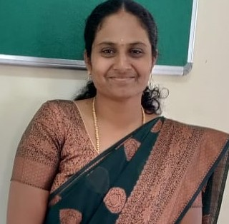
Mrs. C.A.Uma,  MBA. , MSW.,  Assistant professor | 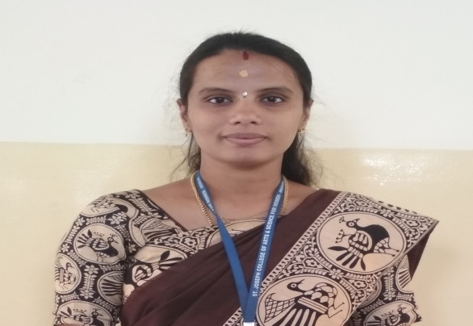
Mrs. C.Suganthi ,  MBA. M.Com.  Assistant professor | 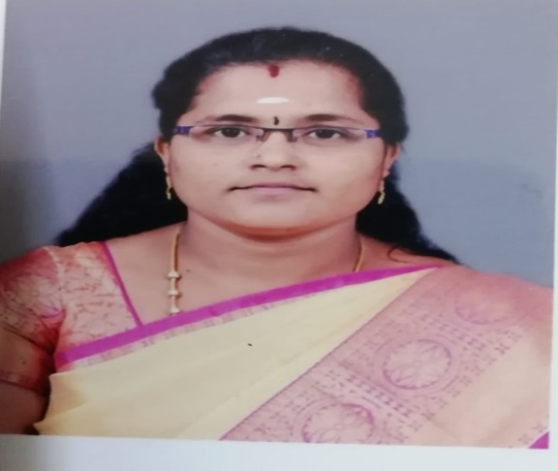
Mrs. D.Saraswathi ,  MBA.,SET (Ph.D)  Assistant professor | 