**Mrs. Margret Kanimozhi M.Sc., M.Phil.,B.Ed., (Ph.d)**



Assistant Professor and Head

Department of Biotechnology



**Ms.Jancy Magdalene P.**  **M.Sc., M.Phil.,**

Assistant Professor

Department of Biotechnology

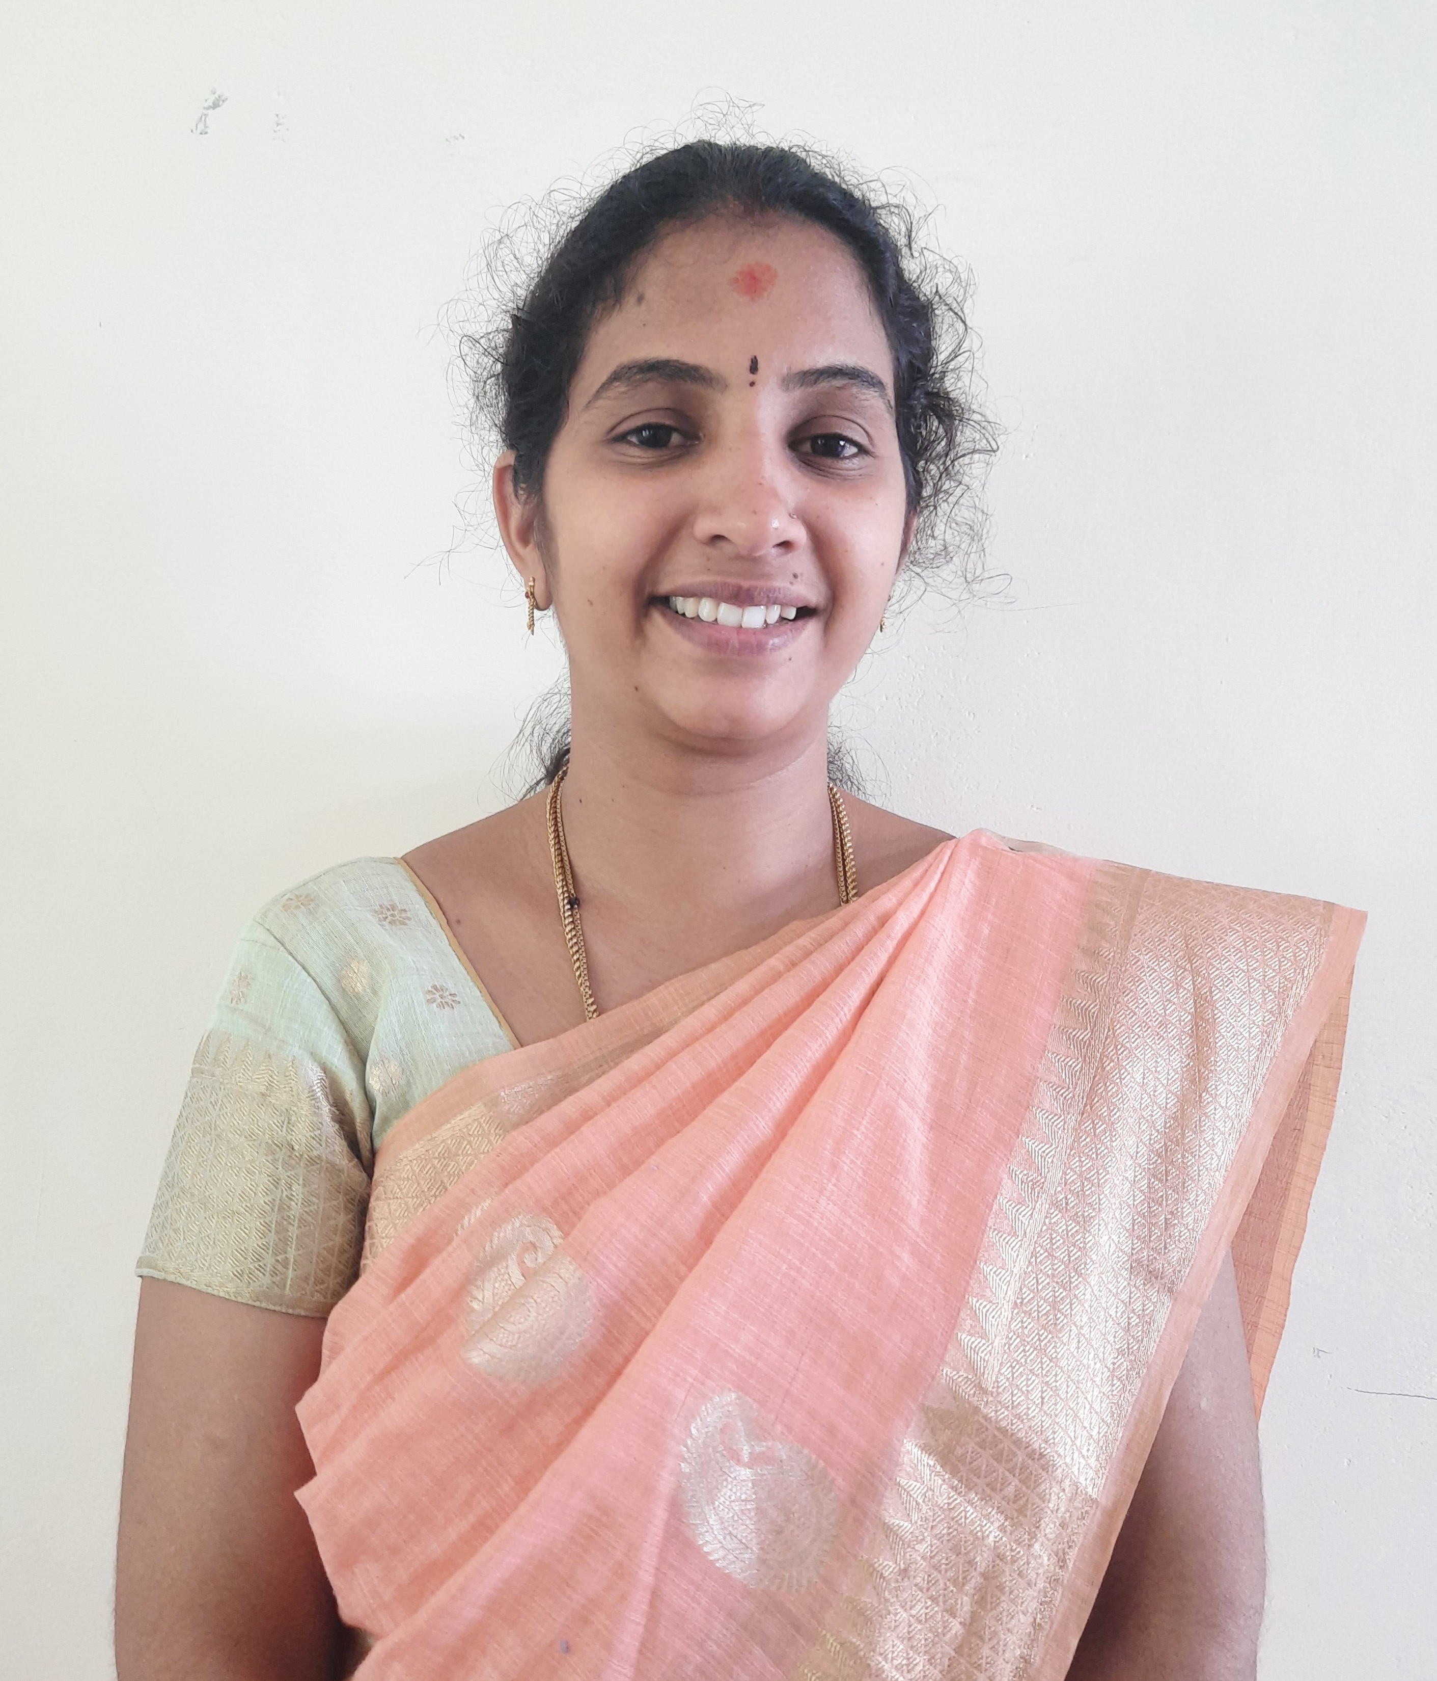

**Mrs. Ramya K.** **M.Sc., M.Phil., B.Ed.,**

Assistant Professor

Department of Biotechnology

**Ms. Lamp Florence R. M.Sc.,**

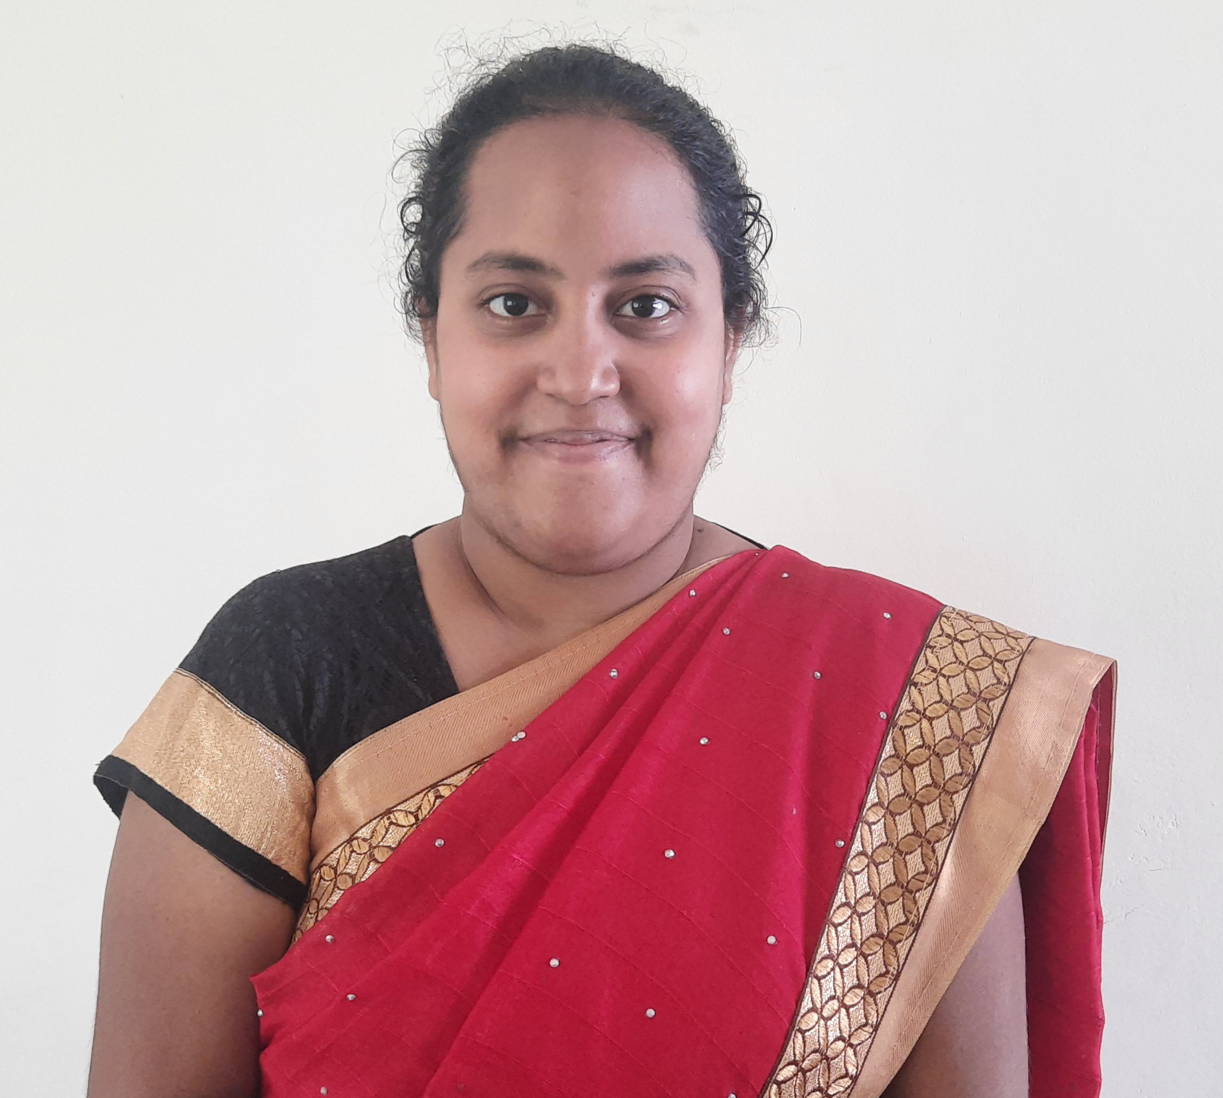

Assistant Professor

Department of Biotechnology