STAFF PROFILE
1 | Mrs.G.G.SHINY RUBIGA  M.Sc., B.Ed., M.Phil.,  Head of the Department | 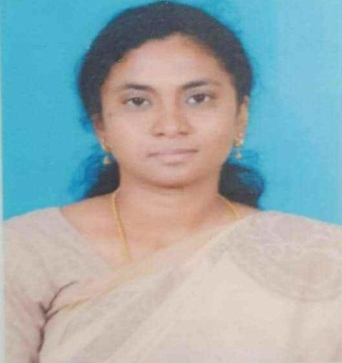
2 | Mrs.S.V.ISHWARYA  M.Sc., M.Phil.,  Asst. Professor | 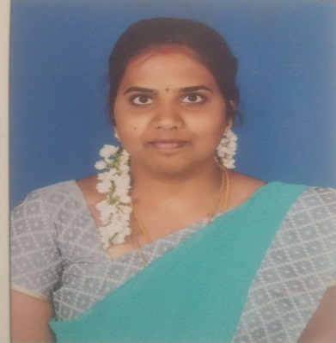
3 | Mrs. M.Swetha  M.Sc., B.Ed  Asst. Professor | 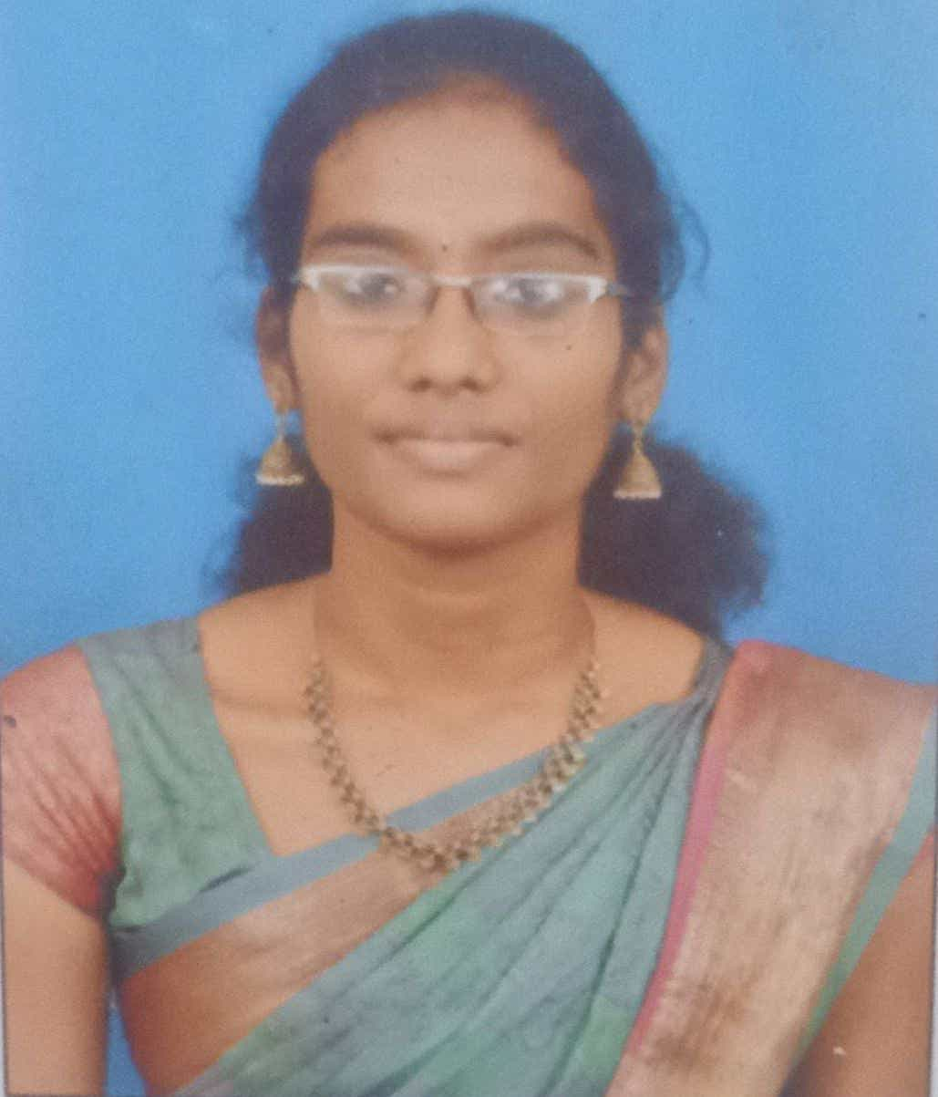
4 | Mrs. C.Mythili  M.Sc., M.Phil.,  Asst. Professor | 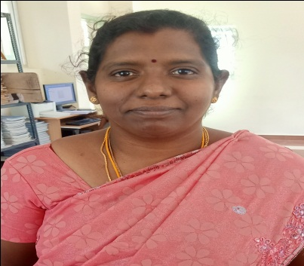
5 | Mrs.Praveena  M.Sc., B.Ed  Asst. Professor | 