**DEPARTMENT LOGO**

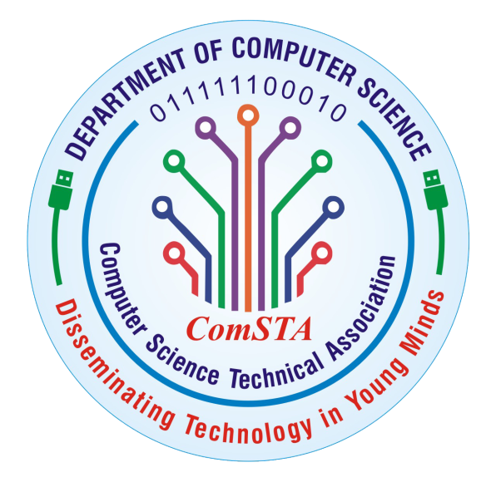

### Aims and Objectives

* Exhibit the best qualities of a liberal, holistic education by becoming knowledgeable, compassionate, moral, well-spoken individuals with prudence.
* Continue pursuing advanced studies, R&D, and other innovative initiatives in science and technology.
* Getting involved in computer science and software development, comprehend the core ideas behind it, and keep advancing their technical skills.
* Be a leader in the community, the workplace, and academia.

**MOTTO**

Disseminating Technology in Young Minds.

**ComSTA:**

**Vision**

To endow young women to acquire specialized knowledge in Computer Science so to succeed in their profession, and contribute to society at large.

### Mission

* Concentrate on the overall development of the students.
* To meet the challenges of industrial need.
* Better the nation through research in science and technology of computing.

**GNOSIS CLUB**

**Vision**

GNOSIS inspires positive action and helps to create an environment of love respect and cooperation in society.

### Mission

* To encourage the marginalized sectors of society.
* To proliferate the food with mortal by providing relevant and responsive programs.

**INTRODUCTION TO DEPARTMENT**

Department was established in the year 2006. We offer B.Sc [CS], B.C.A, B.Sc[DS],M.Sc [CS] and M.Phil [CS] courses with 412 students. The department functions with highly qualified teaching staff to inculcate knowledge and make our students secure excellent results. The computing lab is well furnished with all the required software’s and peripherals as per Periyar University Syllabus. In accordance with our motto “Disseminating Technology in Young Minds”, we bestow the young women to attain technical excellence in the field of Computer Science and Technology. The department provides opportunities and infrastructures for workshops, technical seminars and hands-on training. We strive on imparting self-learning ability, leadership qualities, good career and placement opportunities for our students.