1 | Dr. L. Jenniffer,  M.A., M.Phil.,NET.,Ph.D  Assistant Professor | 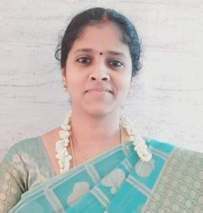
2 | Ms. E. Vinodhini,  M.A., M.Phil., B.Ed.,  Assistant Professor | 
3 | Mrs. L. Anjalin Mary,  M.A., M.Phil., B.Ed.,  Assistant Professor | 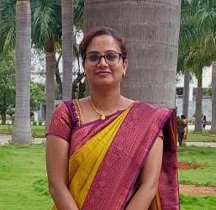
4 | Mrs. V.S.Gladio Shilpa Vince,  M.A., M.Phil.,  Assistant Professor | 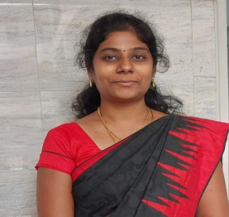
5 | Ms. U. Monisha,  M.A., M.Phil.,  Assistant Professor | 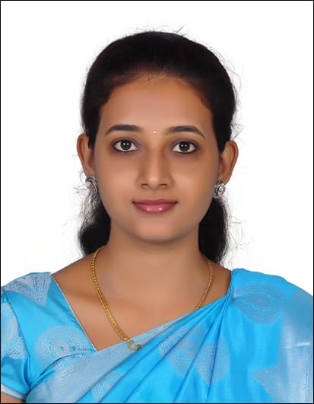
6 | Mrs. P. Vijayalakshmi,  M.A., M.Phil., B.Ed.,  Assistant Professor | 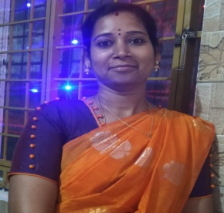
7 | Mrs. S. Julia Persis,  M.A., M.Phil., SET.,  Assistant Professor | 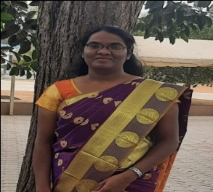
8 | Mrs. P. Prathimasree,  M.A., M.Phil.,  Assistant Professor | 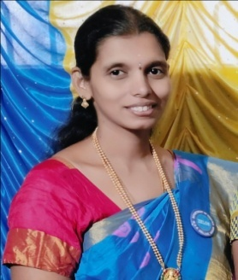
9 | Mrs. S. Pricilla,  M.A., M.Phil., B.Ed.,  Assistant Professor | 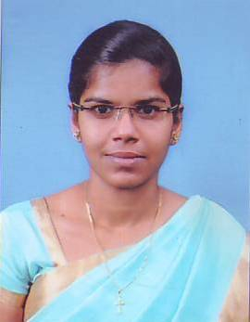
10 | Mrs. M.P. Infant Divya,  M.A., M.Phil., B.Ed.,  Assistant Professor | 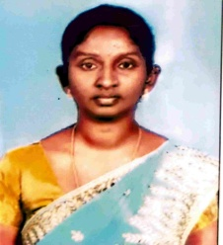
11 | Mrs. R. Kalaiarasi,  M.A., M.Phil.,  Assistant Professor | 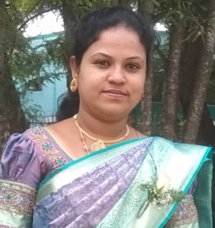
12 | Ms. R. Ayshwaryalatchmi,  M.A.,  Assistant Professor | 