ST.JOSEPH COLLEGE OF ARTS AND SCIENCE FOR WOMEN,HOSUR.
DEPARTMENT OF NUTRITION AND DIETETICS
STAFF PROFILE
S.No | NAME OF THE STAFF | QUALIFICATION | DESIGNATION | PHOTO
01. | Mrs.M.MONICA | M.Sc, NET, (P.hD) | Head and Asst.Professor | 
02. | Mrs.R.PRAILIN | M.Sc, M.Phil | Asst.Professor | 
03. | Mrs.M.DEEPIKA | M.Sc | Asst.Professor | 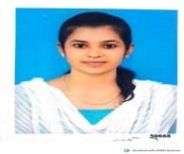
04. | Ms.B.MADHUMITHA | M.Sc | Asst.Professor | 