Dr.P.EZHILARASI  HOD & ASSISTANT PROFESSOR  DEPARTMENT OF TAMIL | 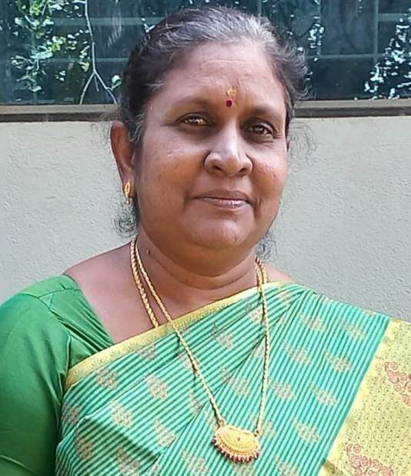
Mrs.C.HEMALATHA  ASSISTANT PROFESSOR  DEPARTMENT OF TAMIL | 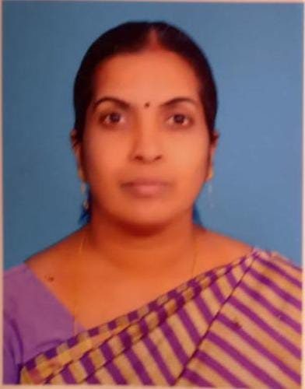
Mrs.E.KAVITHA  ASSISTANT PROFESSOR  DEPARTMENT OF TAMIL | 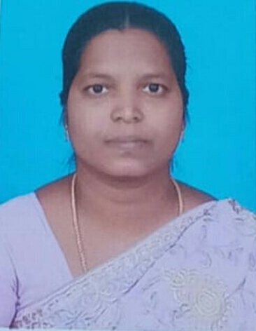
Mrs.N.KANIMOZHI  ASSISTANT PROFESSOR  DEPARTMENT OF TAMIL | 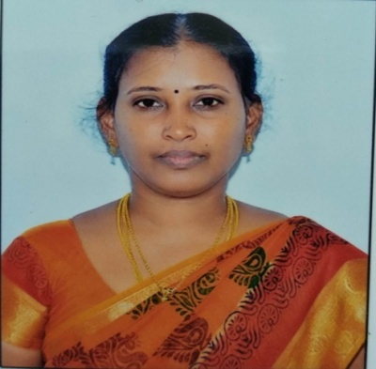
Dr.P.SANGUVATHI  ASSISTANT PROFESSOR  DEPARTMENT OF TAMIL | 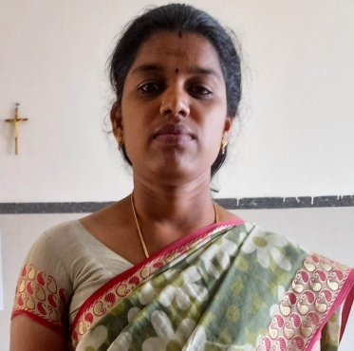
Dr.S.GEETHA  ASSISTANT PROFESSOR  DEPARTMENT OF TAMIL | 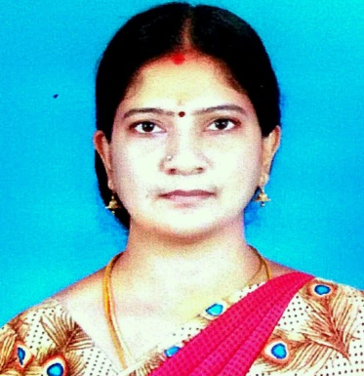
Dr.S.PUNITHA ELIZABETH  ASSISTANT PROFESSOR  DEPARTMENT OF TAMIL | 